REPORT ON THE VİSİT OF PROFESSOR DIDIER HOUZEL TO THE PSYCHOANALYTIC CENTER OF CALIFORNIA, December 5-6, 2015

The IPA component society, the Psychoanalytic Center of California (PCC), had the pleasure of hosting Professor Didier Houzel of France at its 6th Annual Wilfred Bion Conference in Los Angeles, December 5-6, 2015. The event involved a pre-conference workshop, an all-day conference on Saturday open to the public, and two clinical case supervisions on Sunday for PCC members and candidates respectively. Continuing education credits were offered for all events.
On November 17, 2015, PCC member Dr. Jeanette Gadt led a two-hour reading workshop entitled, “Fundamental Concepts: Reading Workshop on the theory and practice of Dr. Didier Houzel.” Attendees read several of Professor Houzel’s published papers in an effort to become familiar with his work in preparation for his visit.

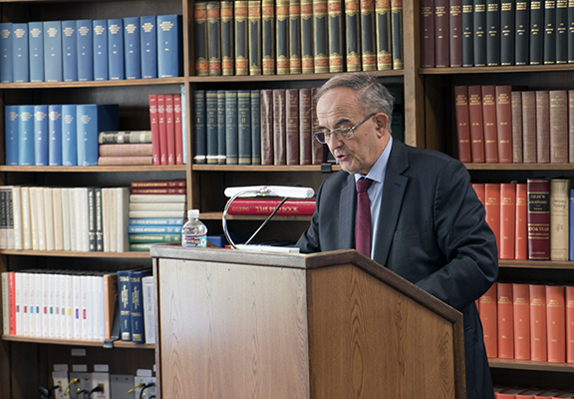
On Saturday, December 5, 2015, the all-day program began with Professor Houzel’s presentation of his paper, The Emergence of the Concept of Catastrophic Change. He explored the roots of Bion's concept of Catastrophic Change in Bion’s early traumatic experiences both in childhood and in the First World War. After a theoretical account of this concept, Professor Houzel shared clinical examples of catastrophic changes in the psychoanalysis of a neurotic patient. He also linked Bion's concept of Catastrophic Change with the so-called Catastrophe Theory developed by the French mathematician René Thom.

In the afternoon, Professor Houzel presented his paper, Orientability and Non-orientability: The Models of Psychic Spaces in Bion's and Meltzer's Work. He explored how Bion's book, Transformations (1965), is devoted to the study of the transformations of the psychic space all along the psychoanalytic process. Bion defines psychic spaces as the places where partial objects used to be, that is as a psychic transformation of the absence of a libidinal object or a "non-realization." The main reference used by Bion here is a topological one. Meltzer (1975), on the other hand, uses a geometrical reference when he defines the dimensionality of the psychic space in his study of child autism. Professor Houzel suggested that the topological concept of orientability and non-orientability can be applied to what Meltzer has described as a bi-dimensional space, which can be understood as resulting from a kind of boomerang effect twisting the psychic space on itself and confusing the internal and the external spaces. He illustrated this hypothesis with clinical material.

There were about 90 people who attended the all-day conference, a mixture of psychoanalysts, candidates, students, and other mental health professionals. Following each paper presentation, the audience engaged in a question and answer period moderated by Dr. Jennifer Kunst, chair of the continuing education committee. This was a thoughtful, respectful discussion hampered only by some challenges in French-English and English-French translation.

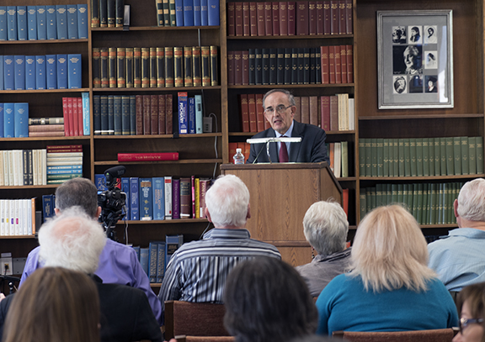

On Saturday evening, PCC hosted a dinner in honor of Professor Houzel with members of the society attending. The evening was filled with delicious food and wine, and lively table conversation.
On Sunday morning, Professor Houzel conducted a two-hour clinical master class with PCC members, with about 25 members in attendance. Dr. Naomi Liebermann presented a challenging case of a young adult woman just beginning to engage in psychoanalytic treatment. On Sunday afternoon, Professor Houzel worked with a group of about 12 candidates, with Dr. Susan Mitchell presenting one of her control cases. The candidates reported that this was an excellent presentation in a collaborative, supportive atmosphere.
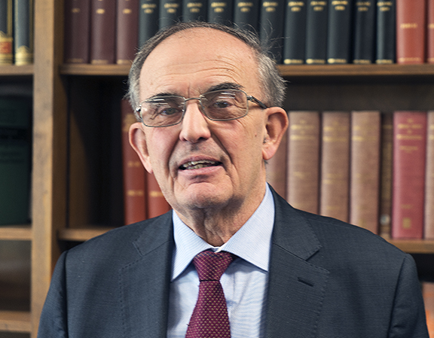
Professor Houzel’s warmth and friendliness were apparent throughout all the activities. PCC is grateful to Drs. Theodore and Judith Mitrani for hosting Professor Houzel in their home.
During and after the weekend, the PCC community had the opportunity to reflect on the differences in the clinical work and thinking of a French analyst in terms of the transference-countertransference, emotional contact, and style of interpretation. These differences were exciting to some and troubling to others, providing much food for thought and highlighting the value of cross-cultural interchange. The PCC is grateful to the IPA and to CAPSA for supporting Professor Houzel’s work with us. Please visit our website soon to see the video of the morning session at www.p-c-c.org.

Respectfully submitted,
Jennifer Kunst, PhD
Chair, PCC Continuing Education Committee

